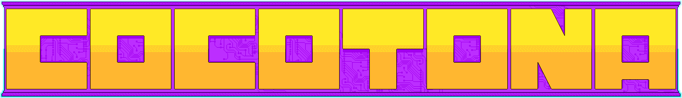
- A cooperative Jump and Run aimed at games-avid, 12+ players for Windows only made by Daniel Bosselmann, Niklas Burrichter, Niklas Weber and Emilia Nilges -

Logline:
Travel as a robot or his companion drone through old mountain ruins and futuristic cyberpunk cities to find your goal and reach your one true destiny.
Backstory :
In an alternate cyberpunk future set in the Aztec mythology a great ever repeating war between the gods has just ended and left the world devastated again. The last god has holed himself up under an dome in which he wants to create a new civilization. But the remaining humans band together to build an behemoth of their own from the parts of the fallen gods to fight the now weakened last god to break the cycle of destruction. They charged the dome with their behemoth but like a wave breaks on the coastline the dome only cracks and the behemoth breaks apart. But a small robot and his drone still managed to get through and now all hope rests with them.
Core Gameplay Loop:
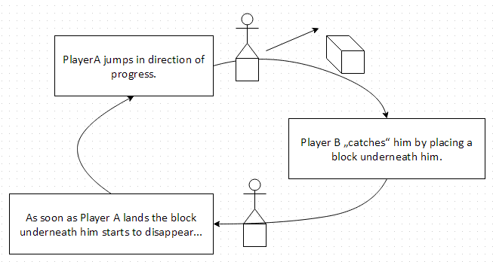
Gameplay:
You run, jump and evade obstacles to reach your goal. While being very hard for you alone luckily you have a friend along with you for the journey. He /She can build platforms over canyons or shelter you from rocket attacks, can stop laser beams from harming you and like a true friend will always catch you when you’re falling.
4-2-1:
The Idea was to take the subject “4-2-1” as a metaphor and translate it into two players have one goal within the four edges of the screen. And then to make the cause for their conflict their common goal.
We used:
As a game engine we used Game Maker: Studio and Photoshop for all art assets.
How we would extend the game:
We would have loved to add a animated Intro and at the end a climactic final boss fight.
Lessons learned:
Highest priority for the next project is to first develop a working design document. By doing that communication between team members would have been easier and the overall game vision would have been clearer.
It would even have helped too choose a fitting scope for the project, which was in hindsight a bit too large.

